**Graph Theory and Combinatorics**

**Assignment Questions**

|  |
| --- |
| **Submission Date: 09-10-2019** |

**1.**  State Handshaking Theorem? Verify Handshaking Theorem for the following graph.

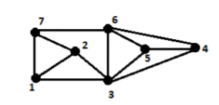

**2.** We are given four cubes. The six faces of every cube are variously colored blue, green, red, or white. Is it possible to stack the cubes one on top of another to form a column such that no color appears twice on any of the four sides of this column?

**3.** Consider the three graphs given below. Check the isomorphism on the following graphs.

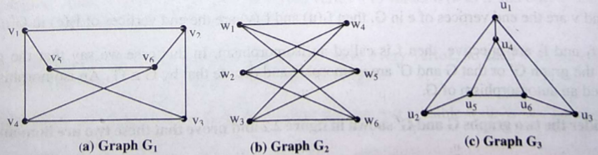

**4.**  Prove that “An Euler graph G is arbitrarily traceable from vertex v in G if and only if every circuit in G contains v “.

**5.**  19 students in a nursery school play a game each day, where they hold hands to form a circle. For how many days can they do this, with no students holding hands with the same playmates more than once? Substantiate your answer with graph theoretic concepts.

**6.**  State and Prove Dirac's Theorem.

**7.** Prove that a graph G with n vertices always has a Hamiltonian path if the sum of the degrees of every path of vertices vi, vj in G satisfies the condition

d(vi)+d(vj)>=n-1